First Person Camera and 3D Character Movement using character controller.

1. Create a new unity project

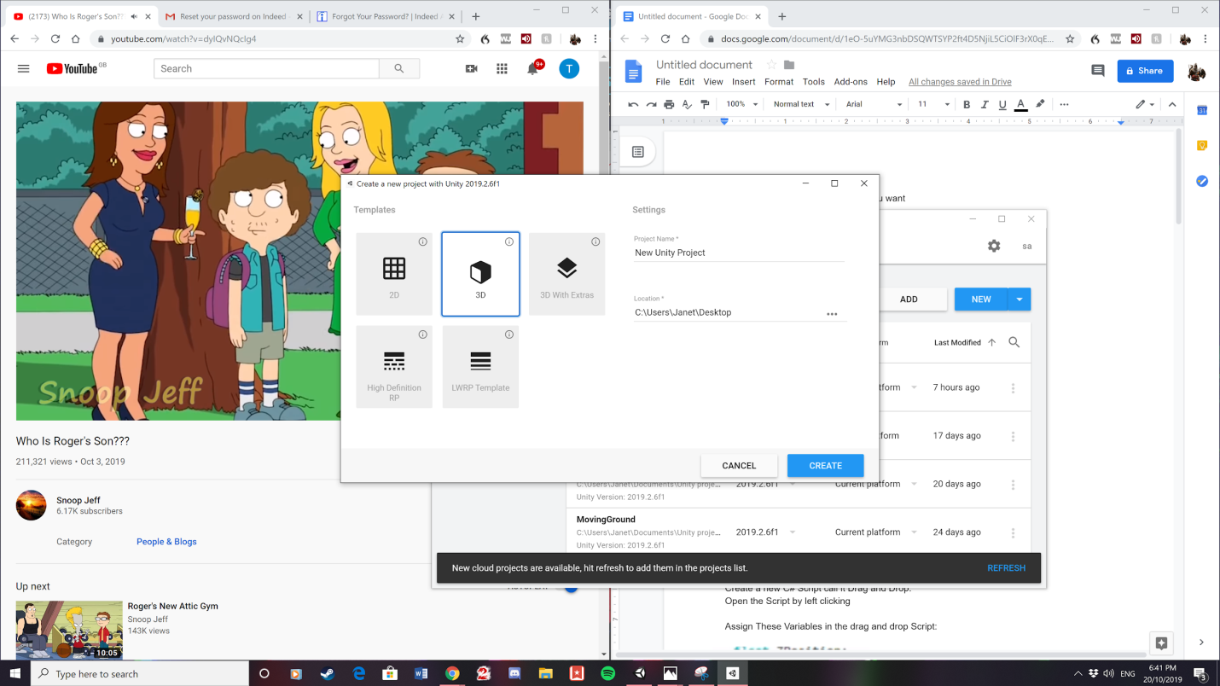

1. Create a Cylinder by left clicking on the hierarchy tab and call it first person Player by left clicking on the cylinder and selecting rename.

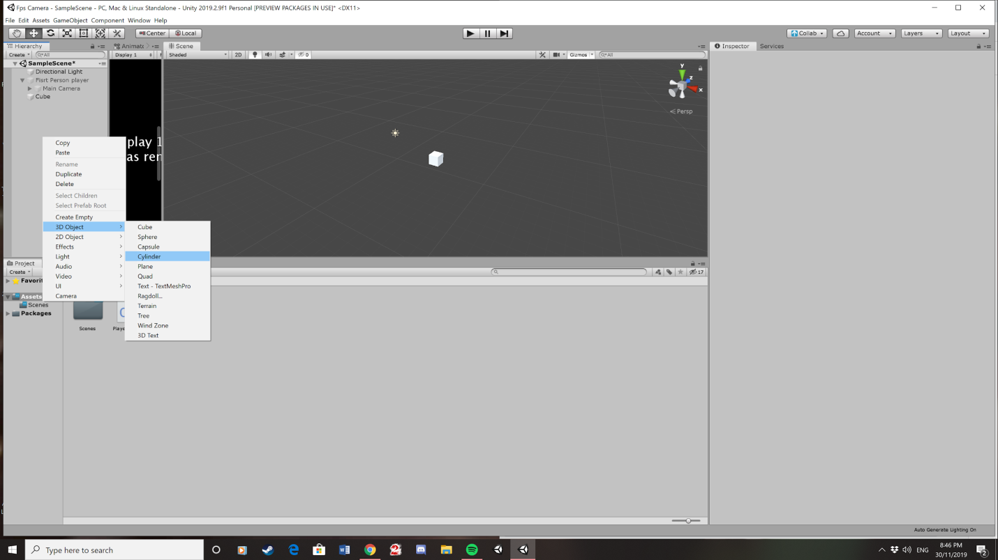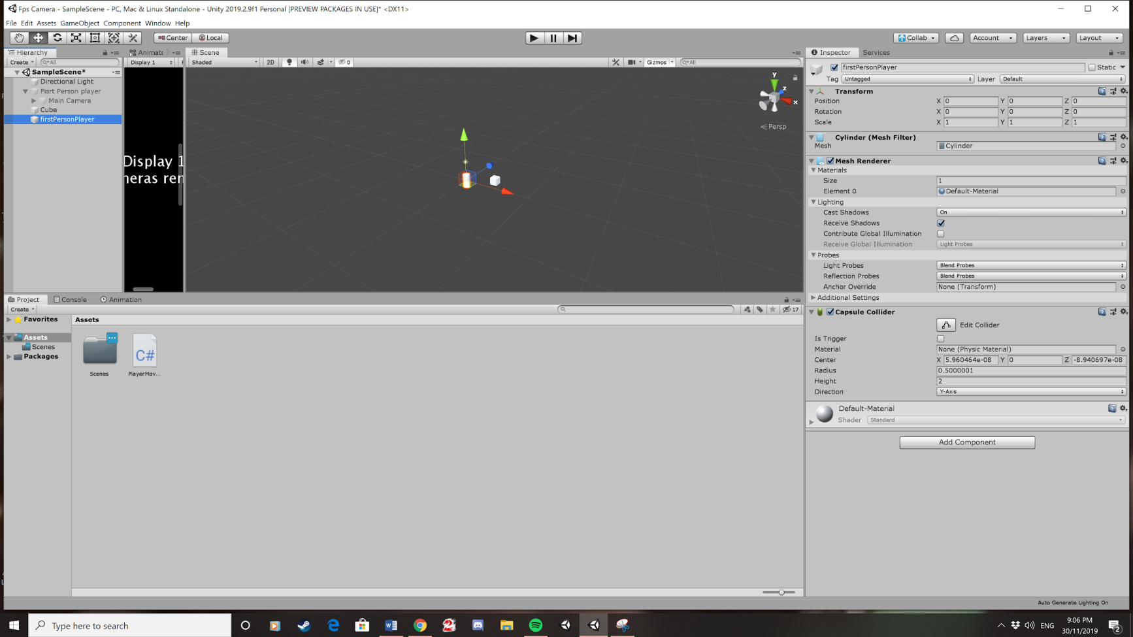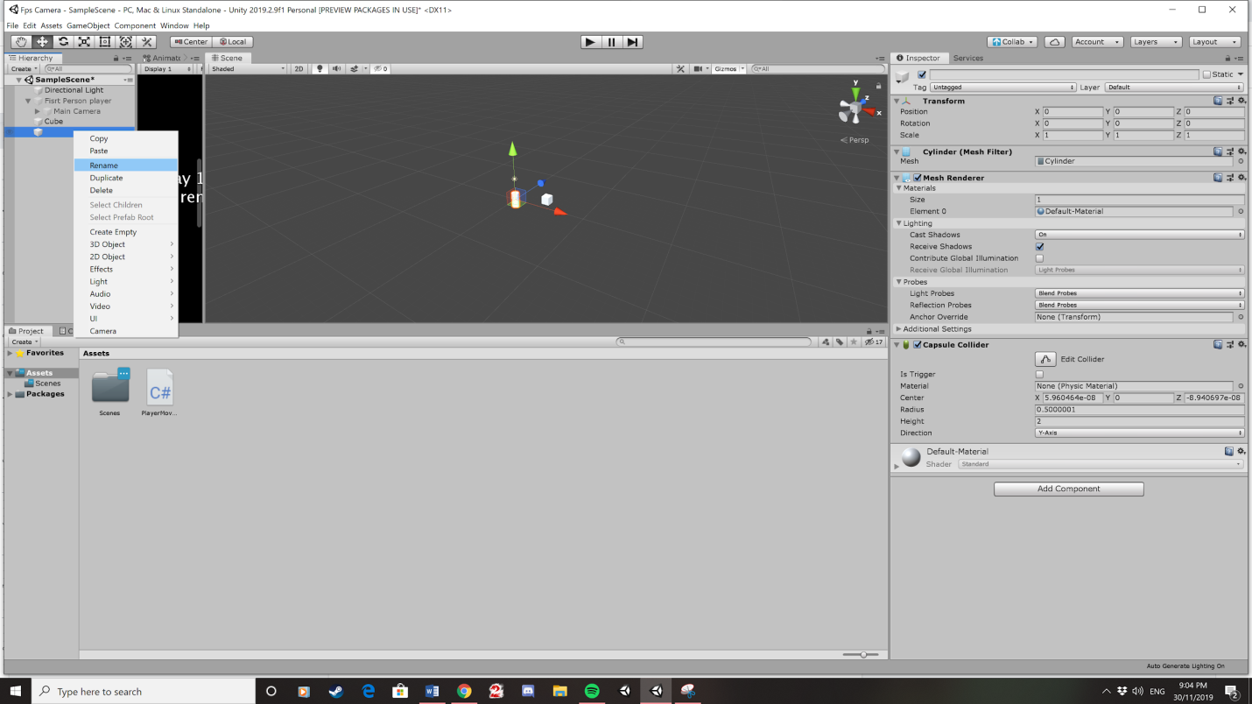

3. Set the x, y and z position of the cylinder to zero by clicking the gear symbol on the transform element.

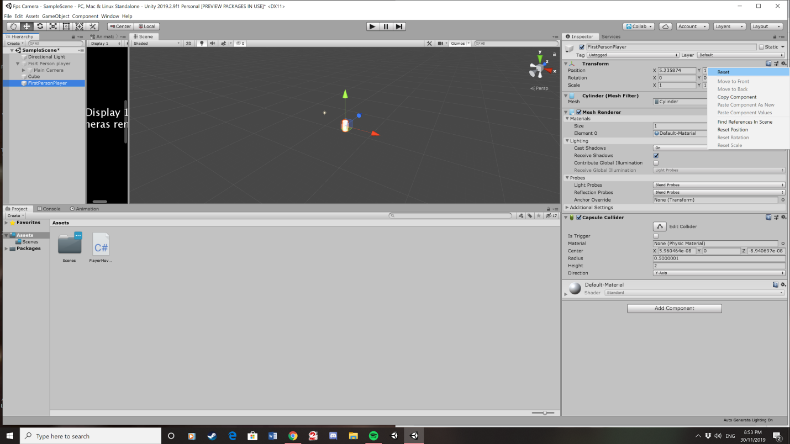

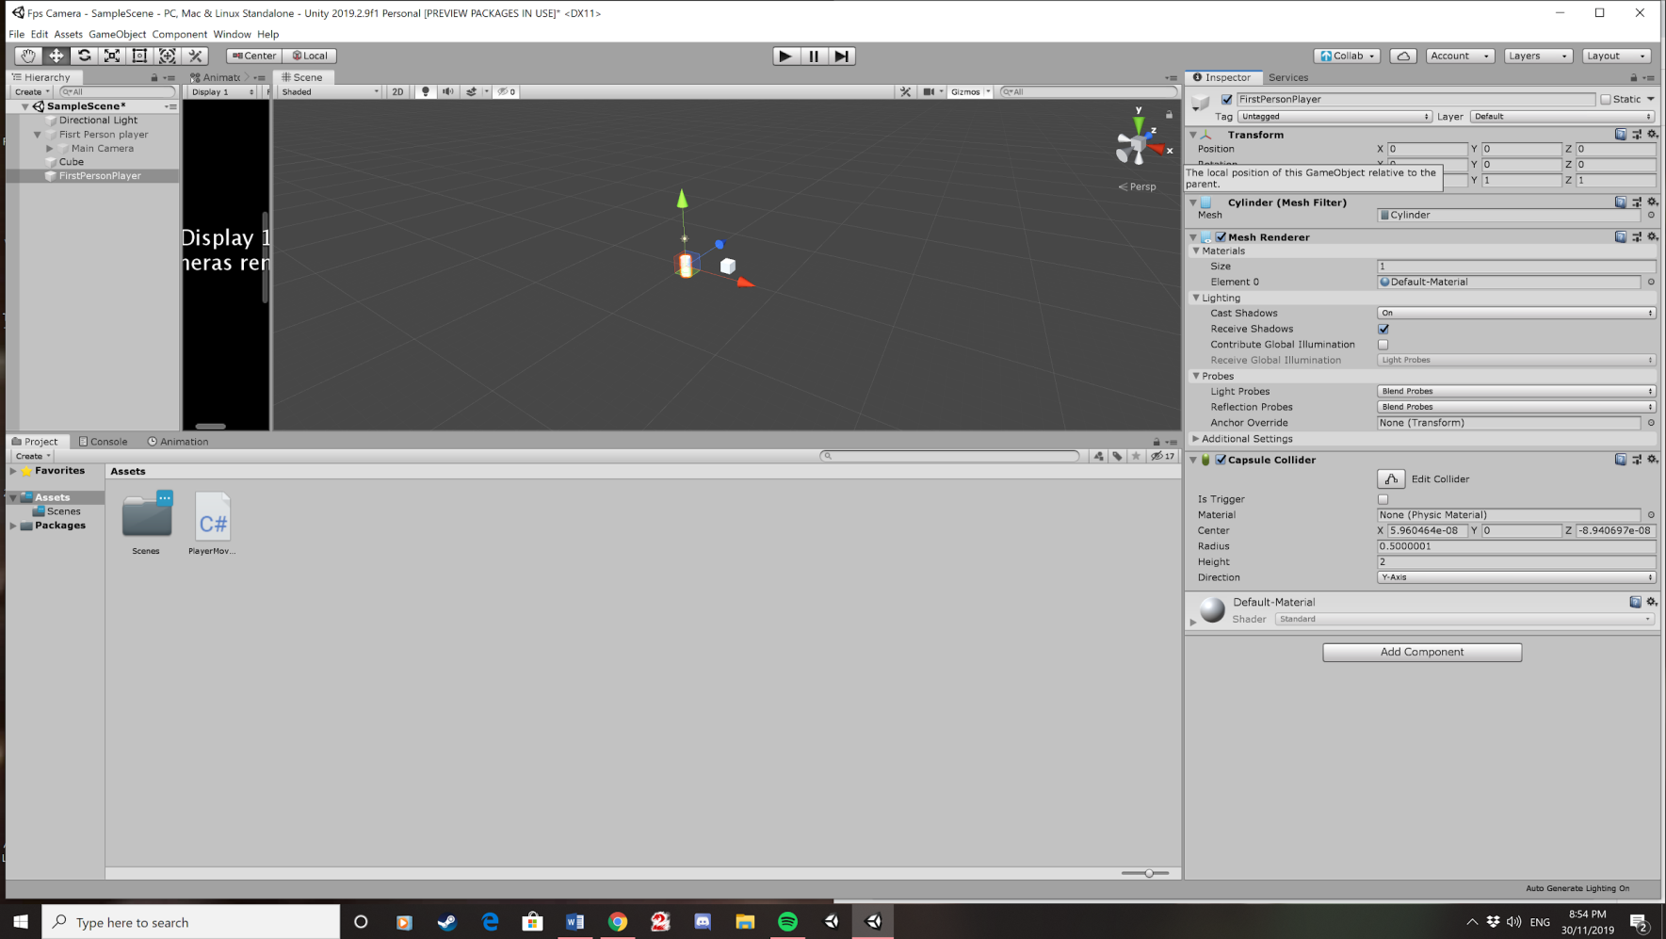

4. Click remove component by clicking on the gear symbol on the capsule collider element. The capsule collider needs to be removed as this will interfere with character controller.

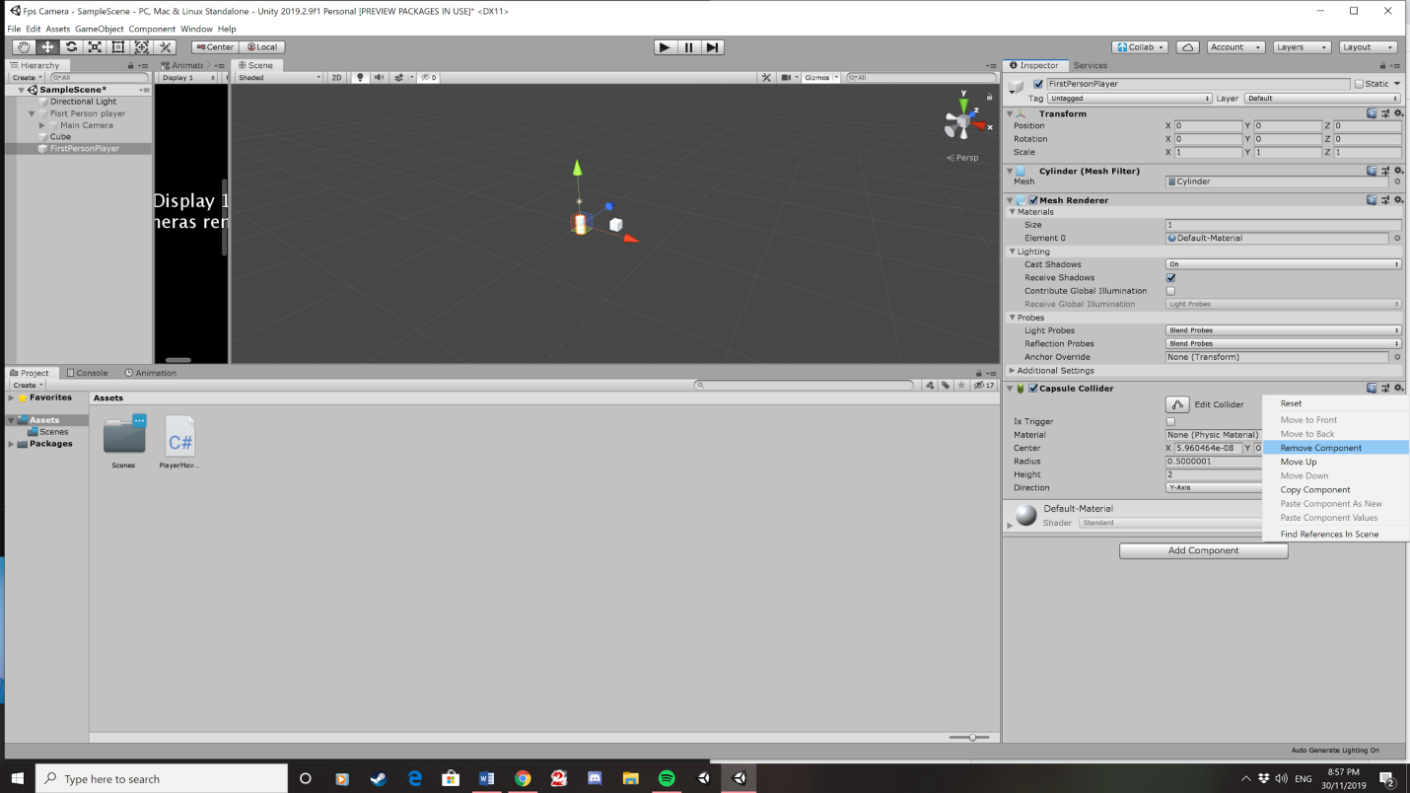

5. Add character controller. You do this by clicking add component on the inspector of the first person player. Then click on physics in component list and then click character controller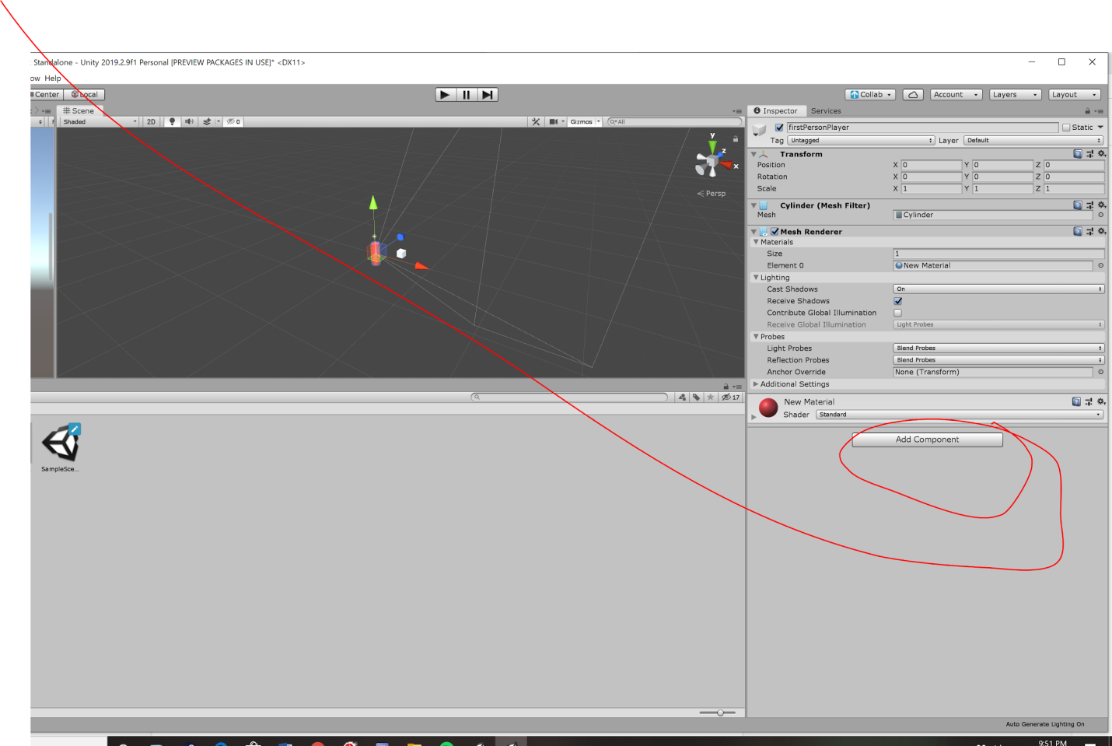

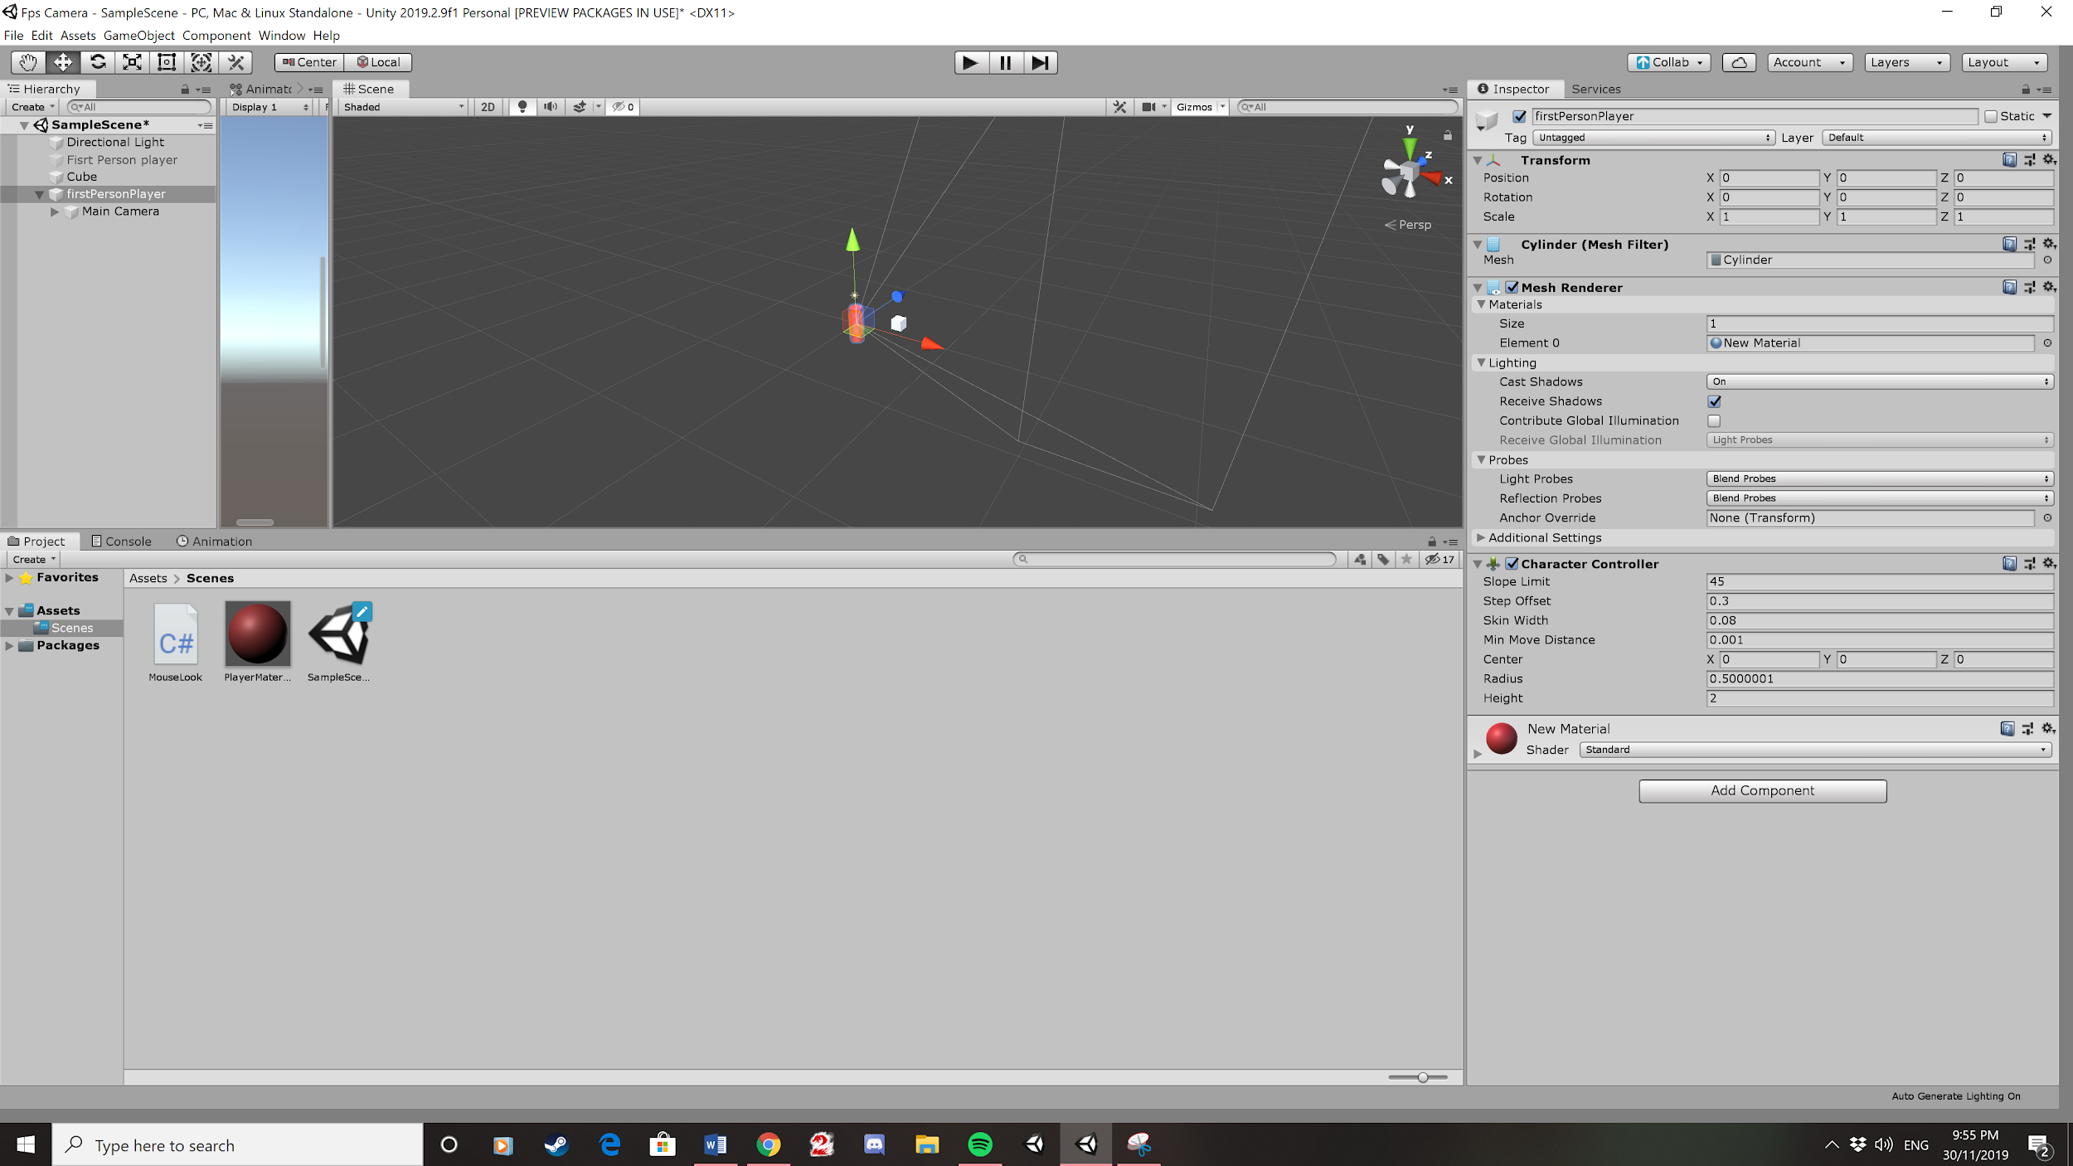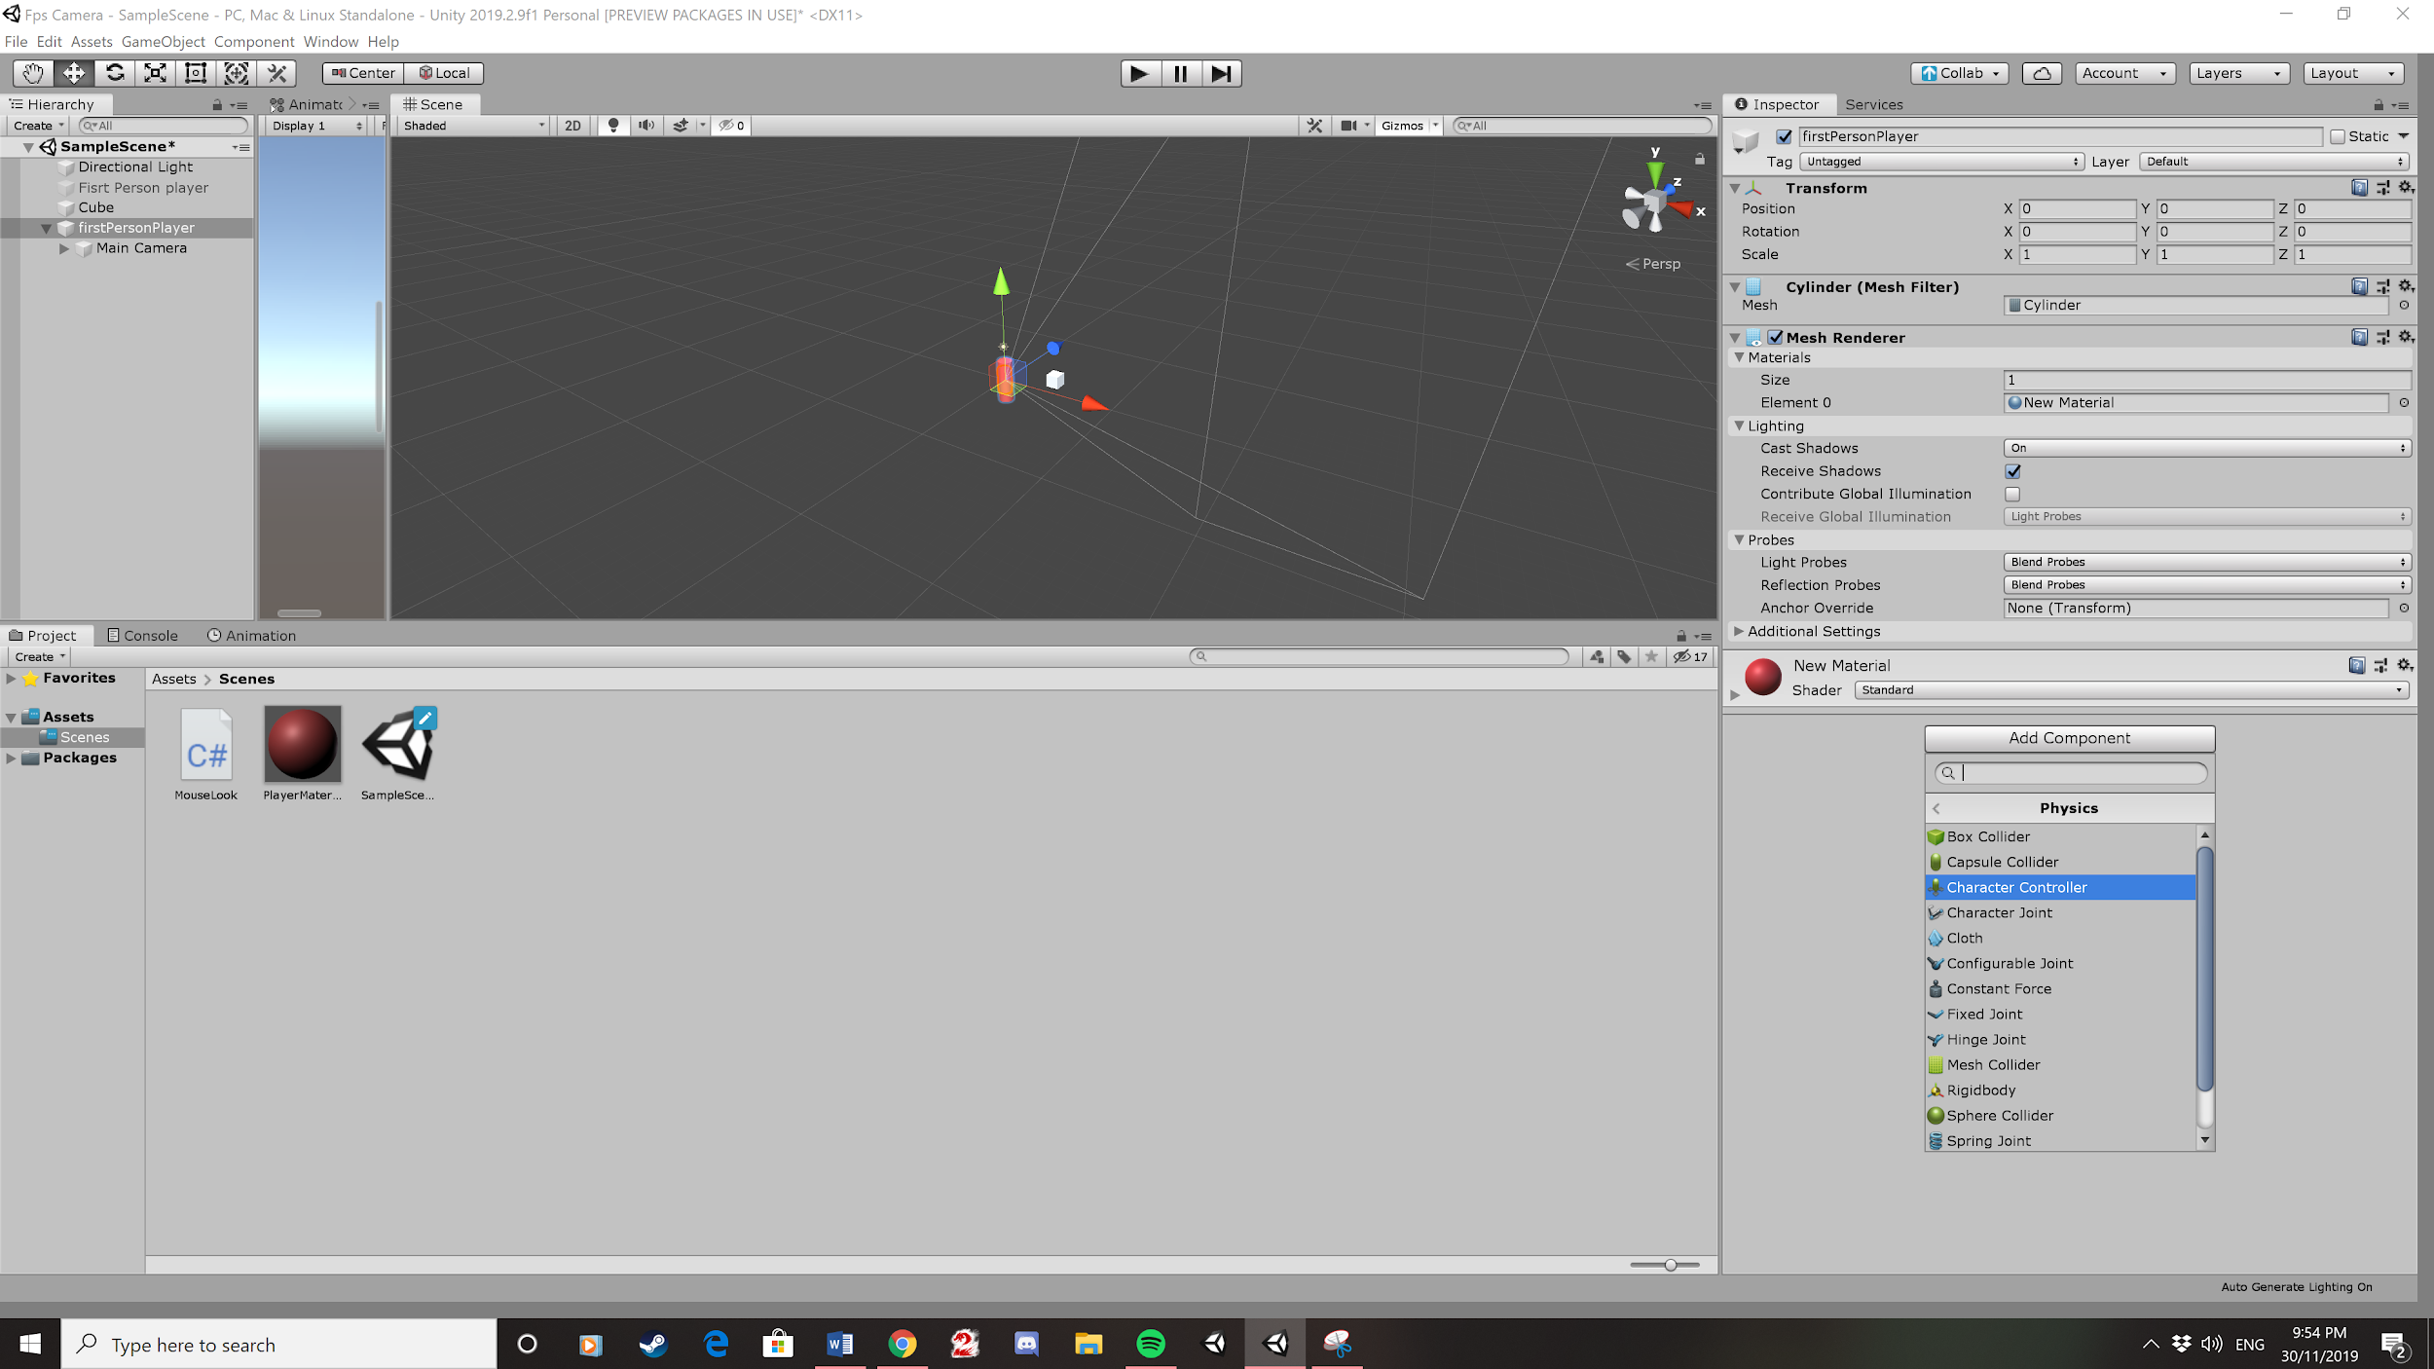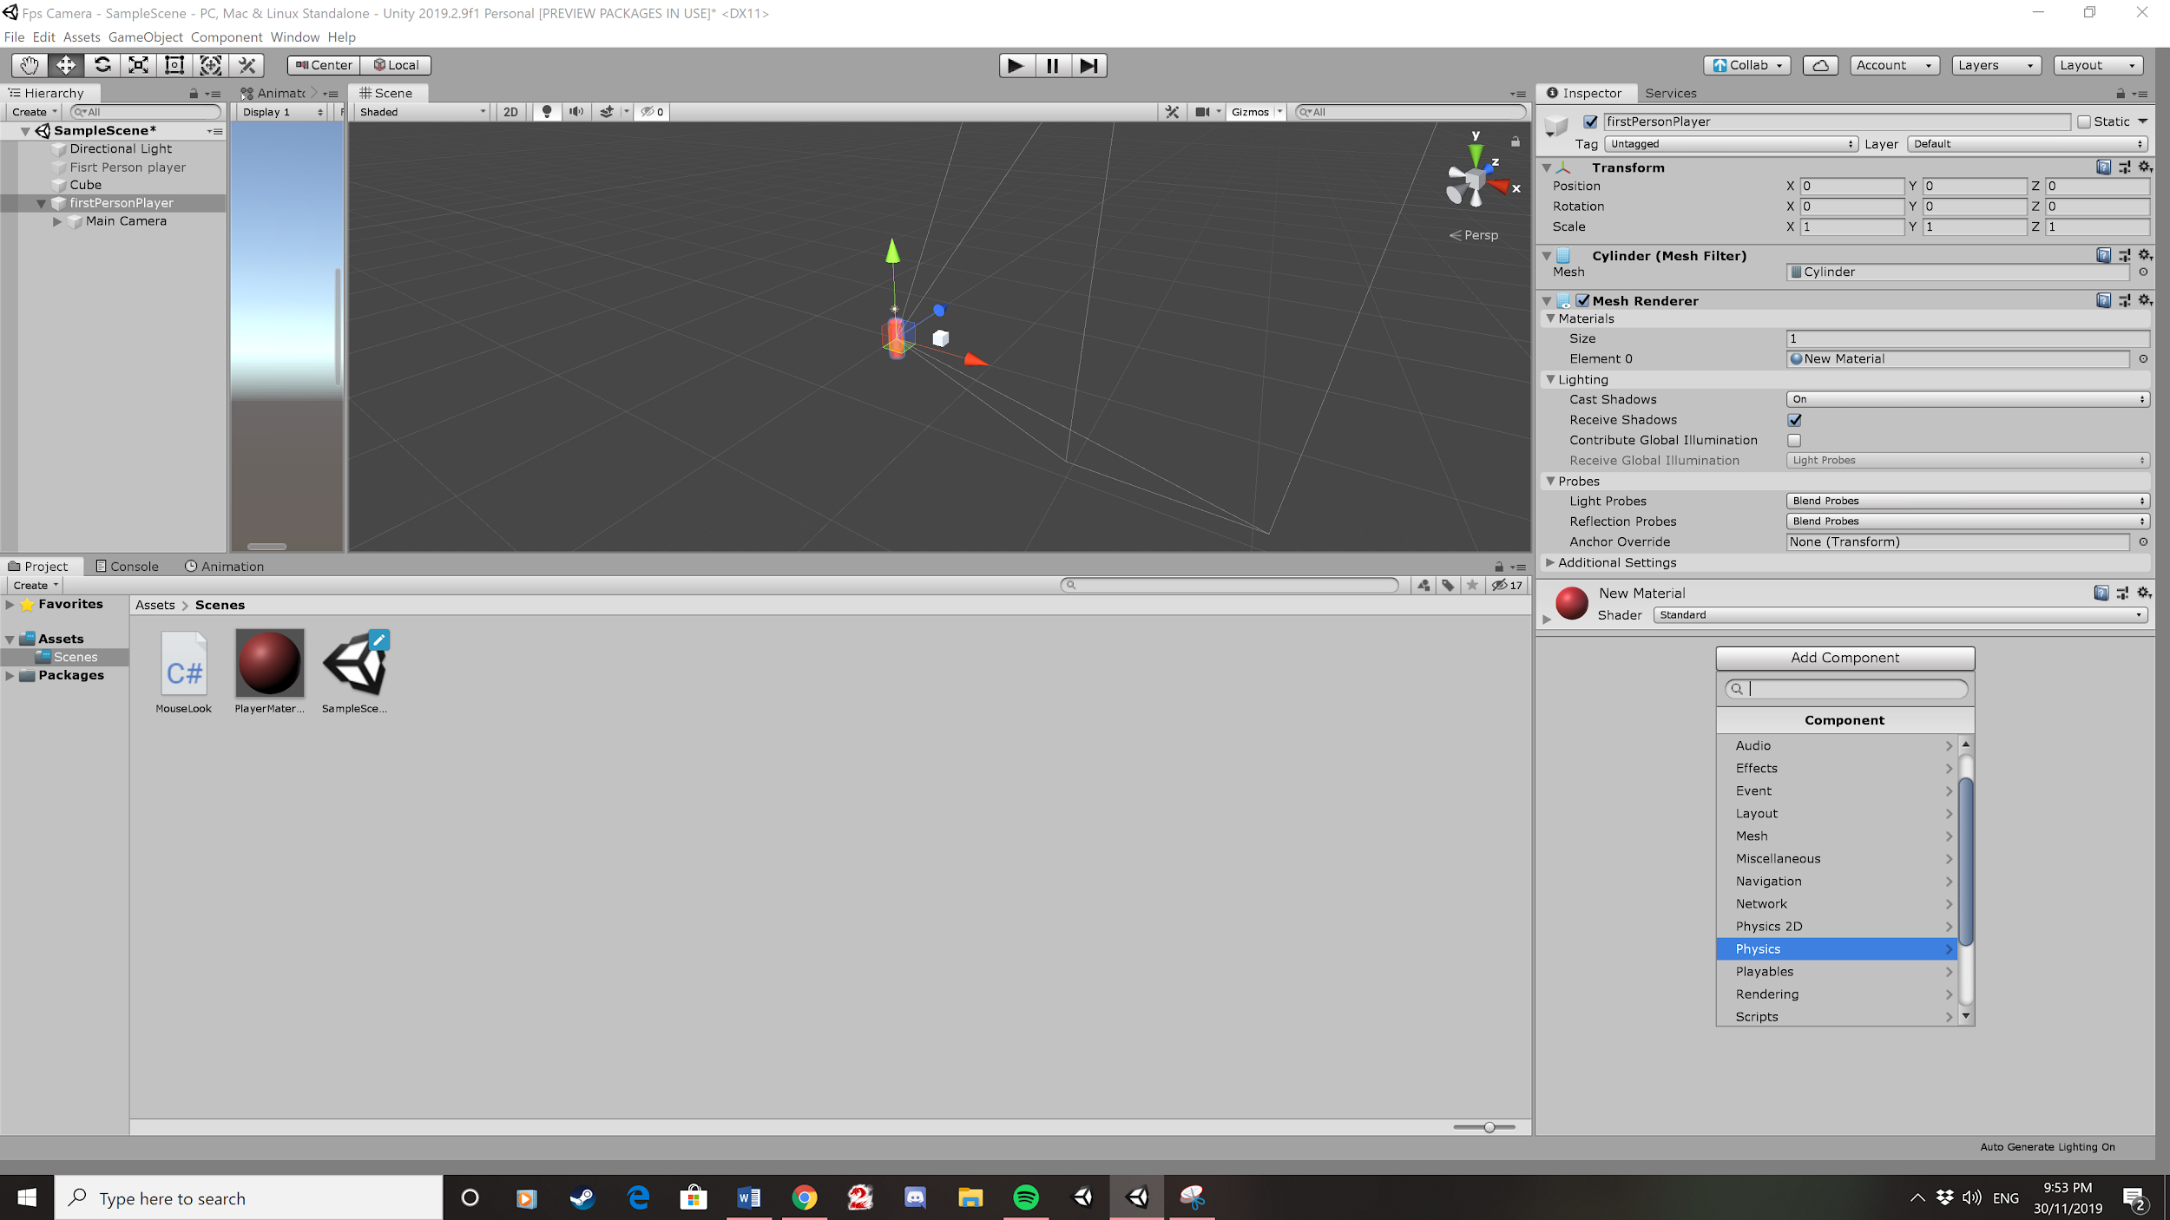

6. Then create a new material

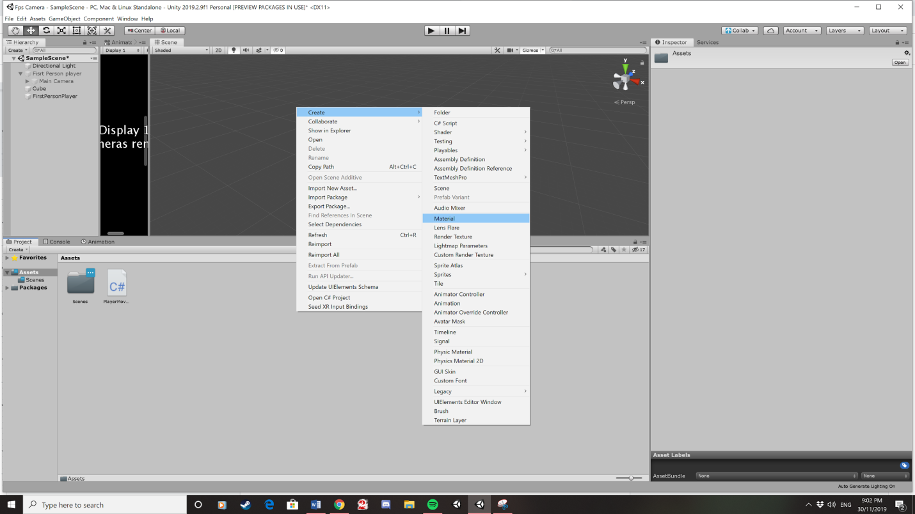

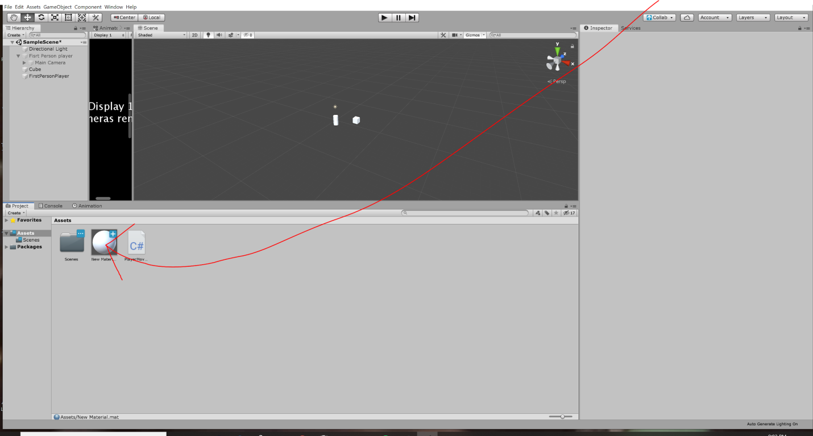

7. Change the Color to red. You do this by clicking on the new material and clicking on where it says Albedo, and then pick red form the color wheel, which opened when we clicked on the Albedo.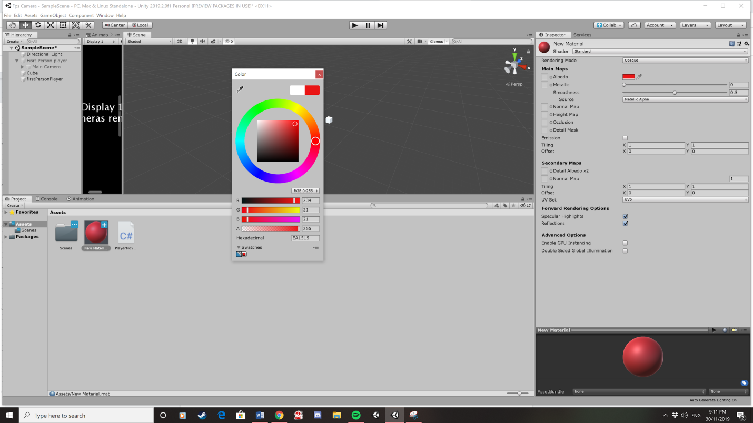

6. Drag the material onto the cylinder.

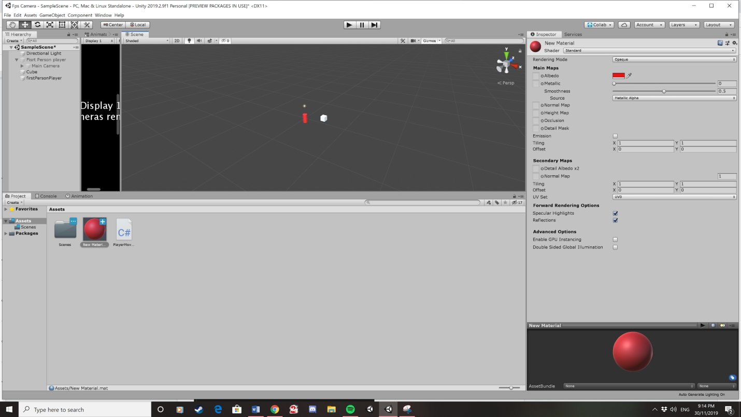

7. Parent the main camera to firstPersonPlayer. By dragging the main camera onto the firstPersonPlayer, then you set the camera position to 0, 0, 0 which is the position we set the cylinder and is done the same as the cylinder.

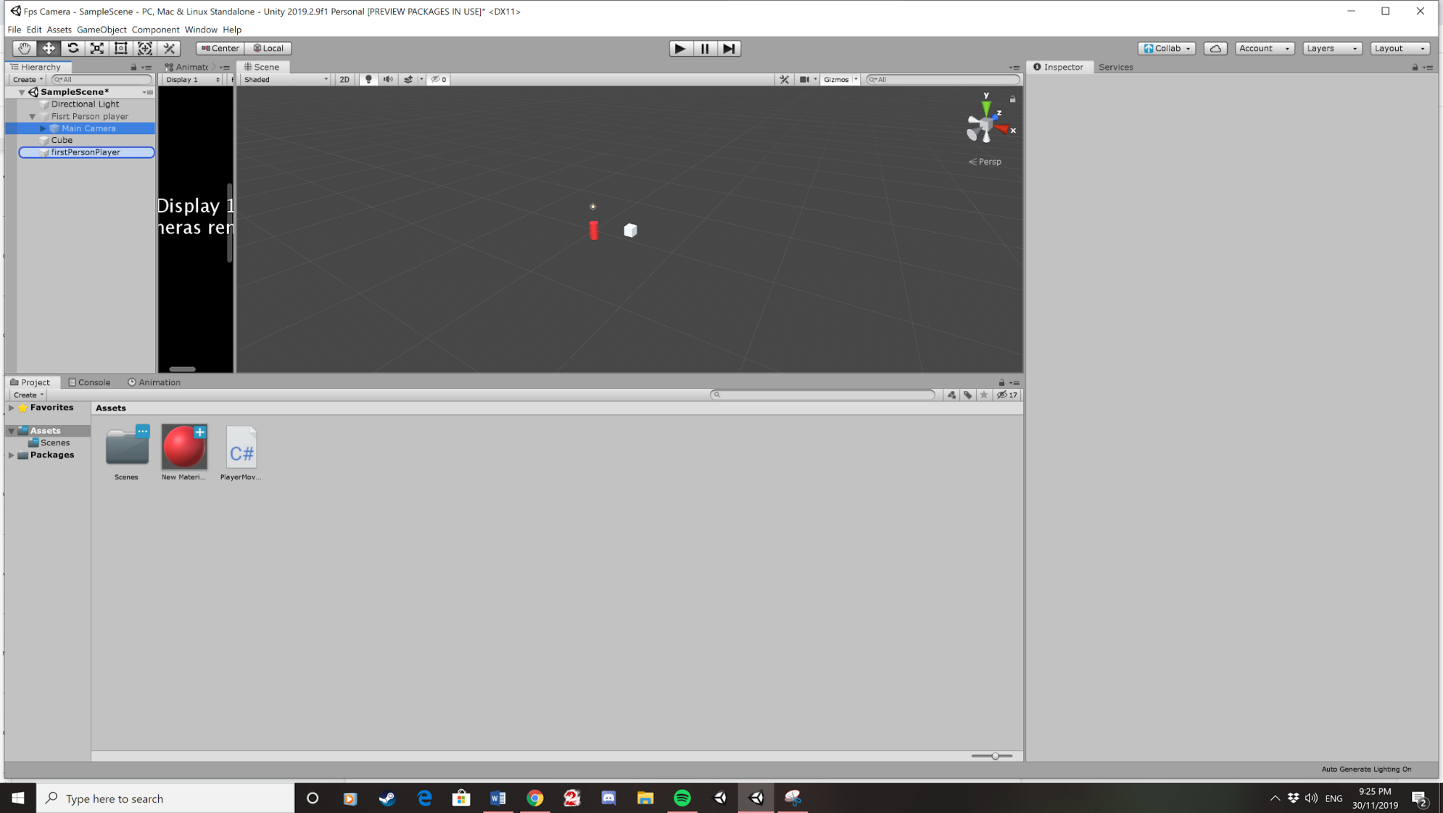

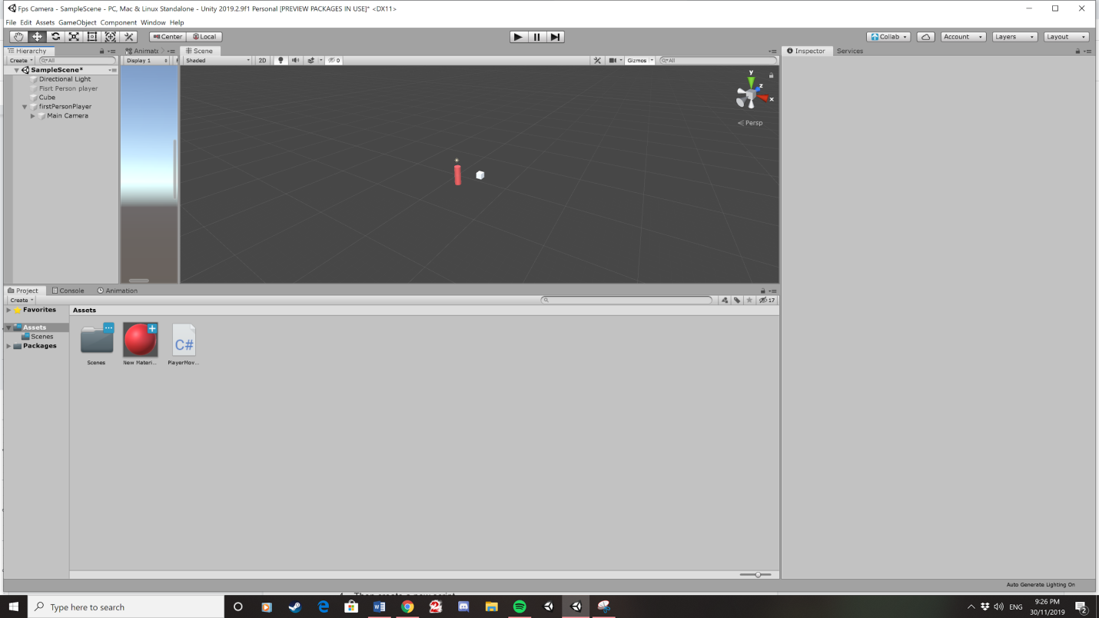

8.Then create a new script

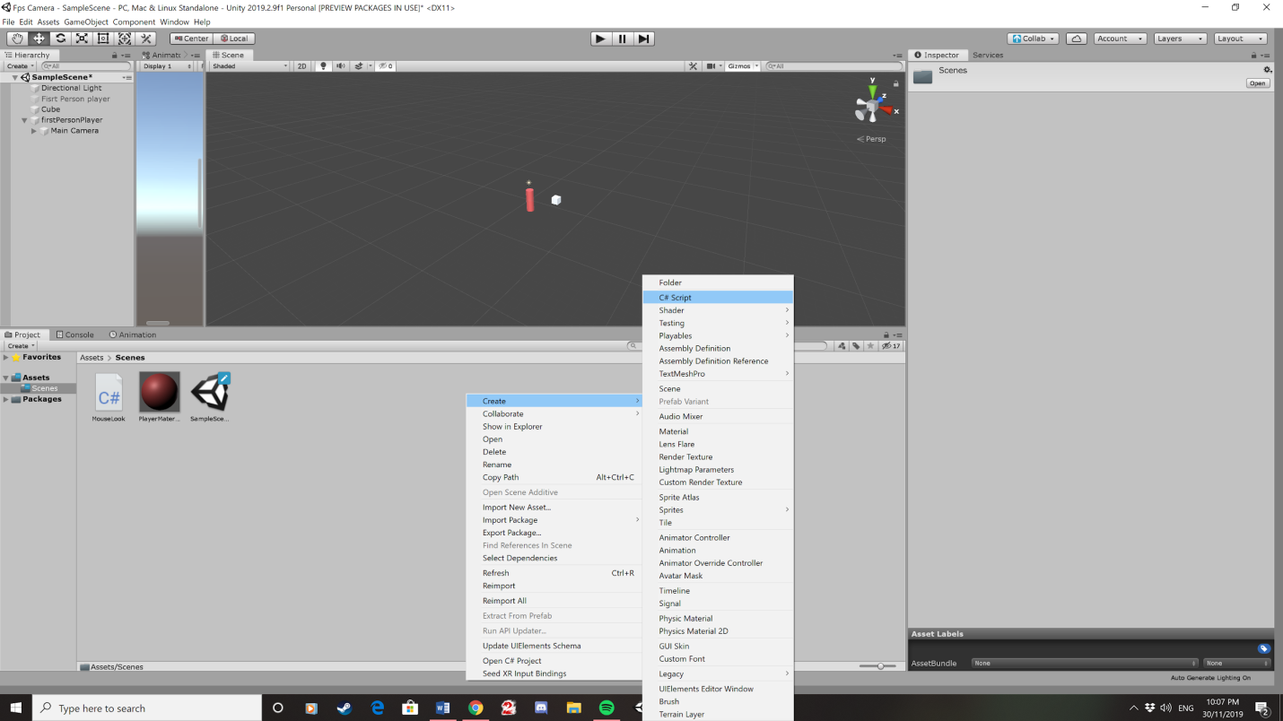

9. Call it mouse look by rename the script like we did with the first person player object. This will allow us to look around the 3d environment using the mouse.

10. Open the script by clicking on it which will open visual studio code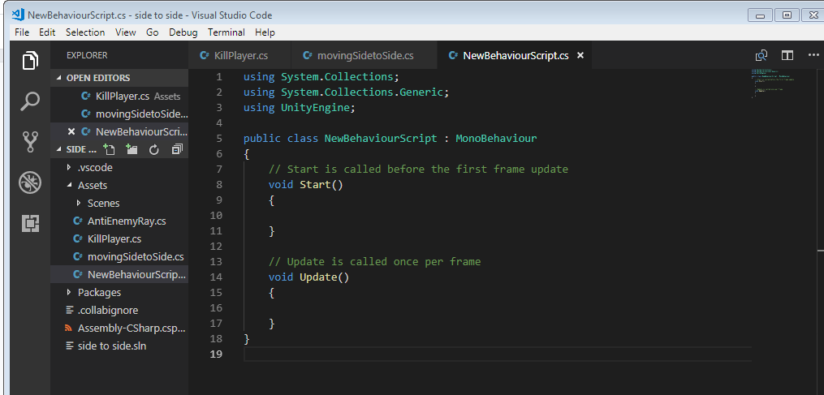

11.Copy this code expect the public class mouse look. After you have copied the code press ctrl S to save the code

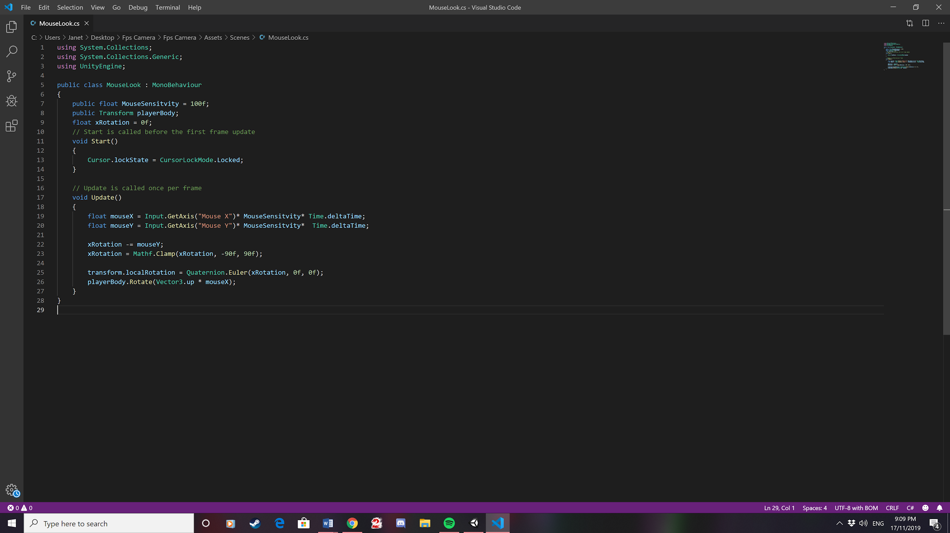

12. Then drag this Script onto the camera.

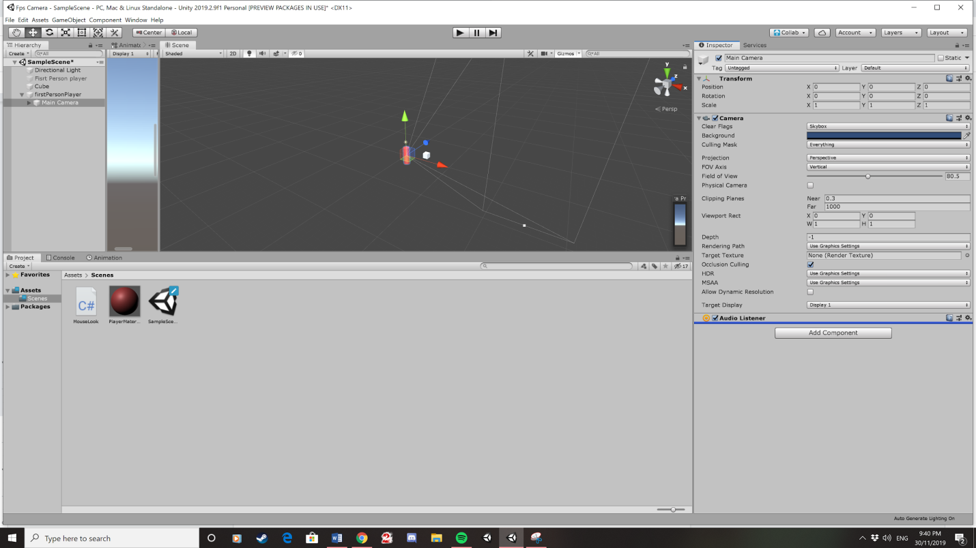

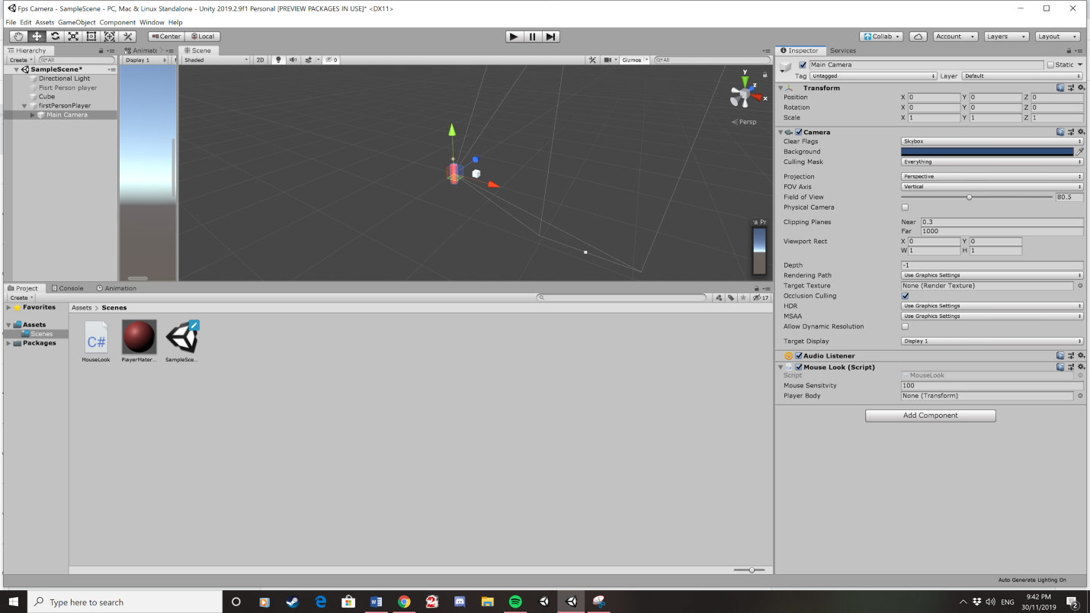

13. Drag the first person player to where it says player body

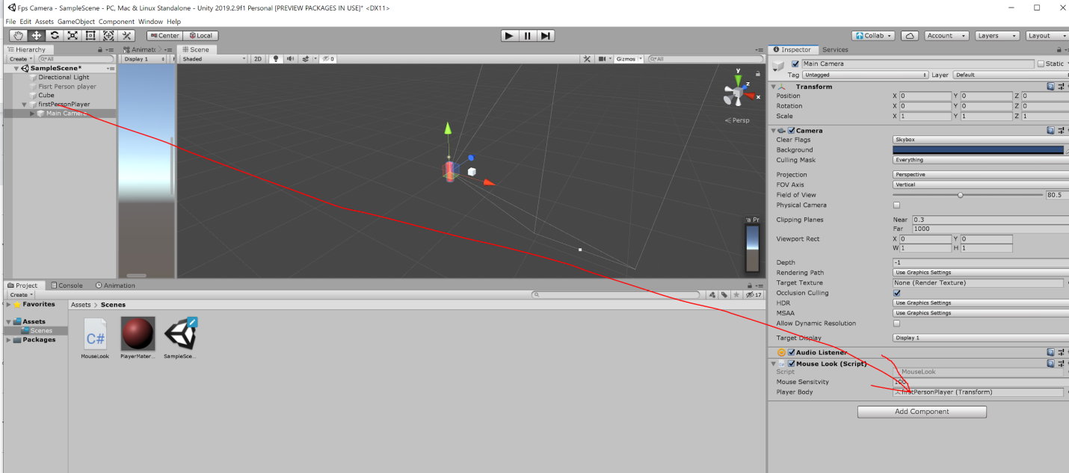

14. Create a new script. Rename it as PlayerMove3D.

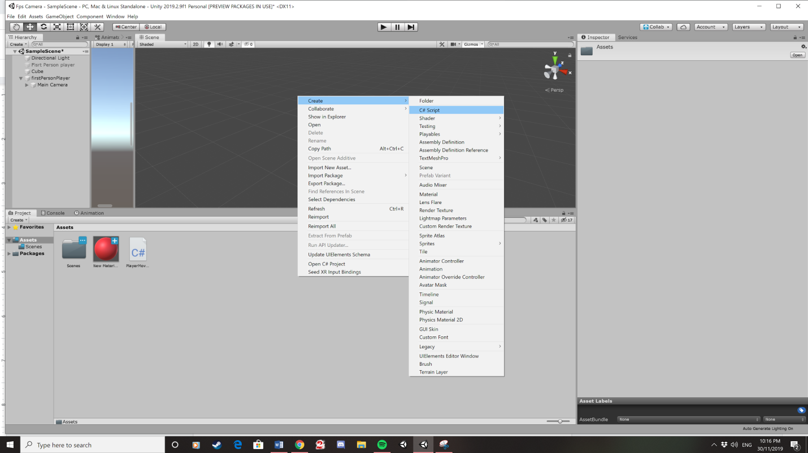

15. Use this code to make the character move in 3d using the character controller. Copy this code everything expect public class PlayerMove3D.

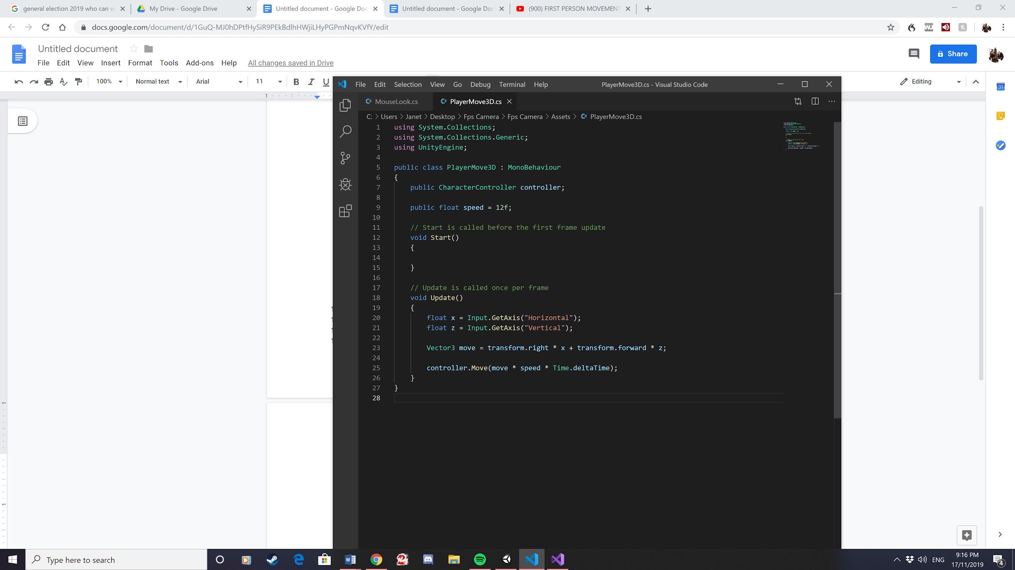

16. This is what the scene should look like.

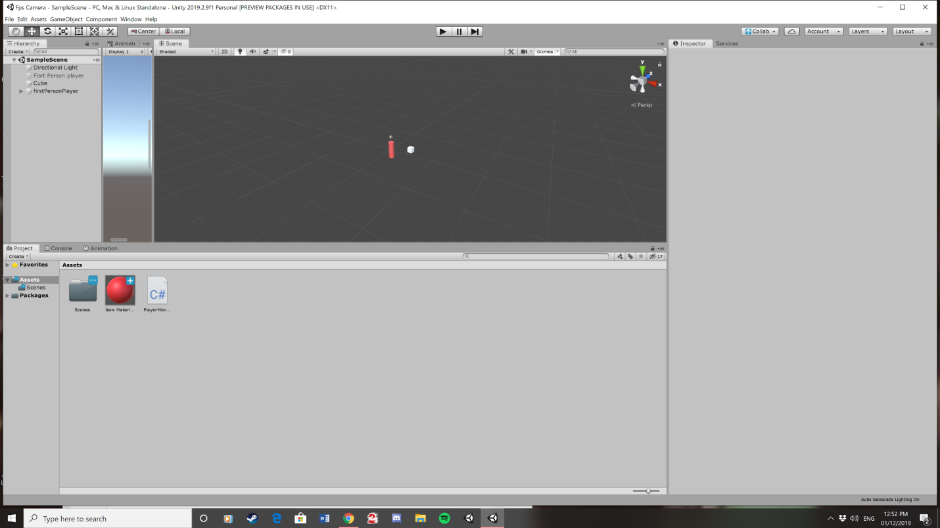

17. Press play to get all the code to work.